**Color blind accessibility android app**

1. Download the code from https://github.com/milk-modules/Apps/tree/master/non-accessible/DemoApp02-BalloonSimple
2. Import project in to Android studio
   1. Open Android studio.
   2. Import project in Android studio

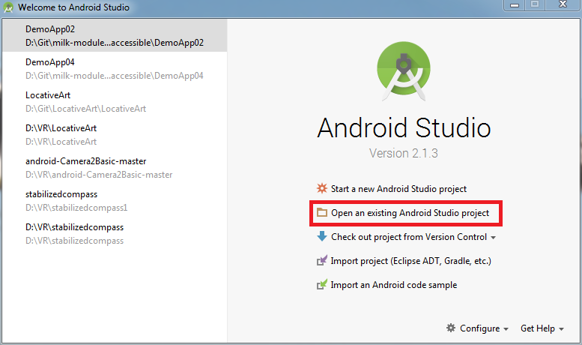

* 1. Run the project using the emulator

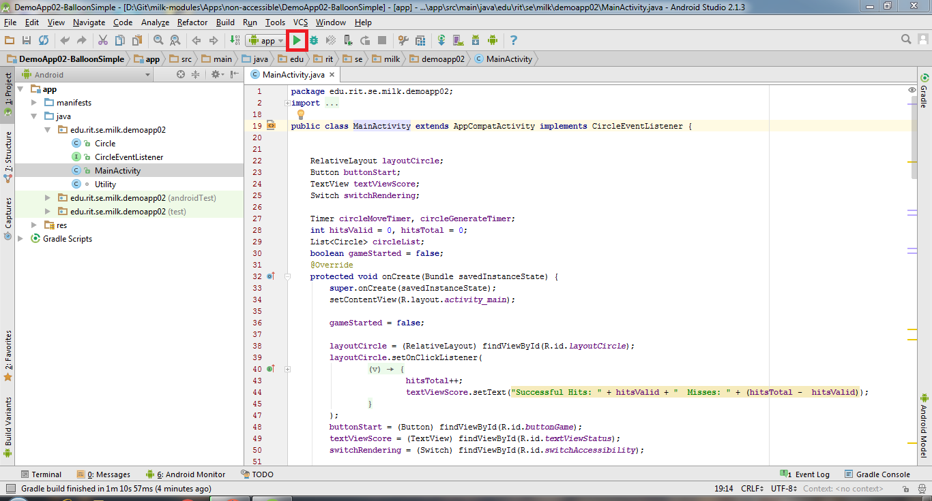

1. You will be able to see an app that is non-accessible to color-blind users.

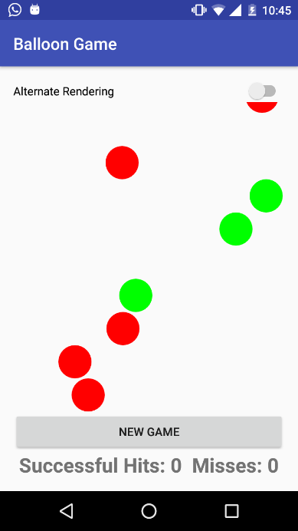 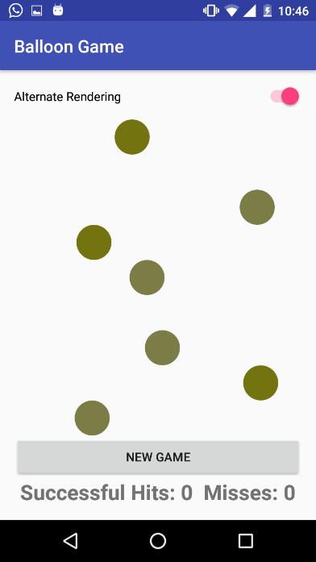

1. To fix this follow the following steps:
   1. Open Circle.java file
   2. On line 36, paste the following code

**if**(**isPoppable**) {  
 Paint paint = **new** Paint();  
 paint.setColor(**textColor**);  
 paint.setTextSize(64f);  
 paint.setAntiAlias(**true**);  
 paint.setTextAlign(Paint.Align.***CENTER***);  
  
 canvas.drawText(**"+"**, **x**, **y** + **circleRadius** / 2, paint);  
}

* 1. Run the project again and see the difference

